Booth Application
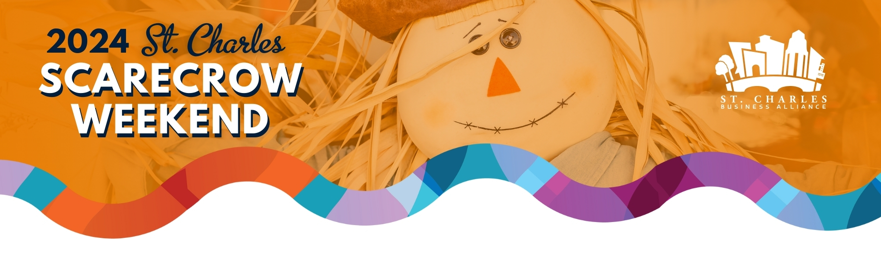

October 11th – October 13th
Participant Requirement:
- Booth must be open and active during ALL Festival hours: Friday (12pm-6pm); Saturday (10am-6pm); and Sunday (10am-5pm)
- Participant must have an approved family friendly activity at their booth. (ie., Art Activity, Face Painter, Children’s Giveaways, Games, Photo-op)
- Participant may not sell anything from their booth- Free items may be handed out.
- Create a Scarecrow
Details
- Booths will be located at The Family Zone in Lincoln Park
- There are a maximum of 15 booth spaces available for Scarecrow Weekend 2024 - Book fast!
- Each participant will be provided (1) 10x10 tent, (1) 6ft table, and (2) chairs.
- Total cost: $2000
- Deposit required: $500.00

Mail or email your Application by: September 1st, 2024
St. Charles Business Alliance
Attn: Scarecrow Booth Application
2 E. Main Street, St. Charles, IL 60174
Email: info@stcalliance.org

PLEASE PRINT OR TYPE ALL INFORMATION
Business/Organization: ________________________________________ Will you be participating in the Scarecrow Contest? _______
Contact Name: ______________________________________________ Phone: _________________________________________________
Email Address: ________________________________________________________________________________________________________
Onsite Contact (if different): ___________________________________ Cell Phone: _____________________________________________
Provide Detailed Description of your Booth: ________________________________________________________________________________________________________________________________________________________________________________________________________________________________________________
Provide Detailed Description of your Family Friendly Activity (to be approved by St. Charles Business Alliance): ________________________________________________________________________________________________________________________________________________________________________________________________________________________________________________
By signing this entry form, I hereby agree to the booth rules as listed on the bock of this application. I release/hold harmless The St. Charles Business Alliance, its employees, officers, and agents from any and all claims for loss, damage or injury incurred by participation in the St. Charles Scarecrow Weekend.
Signature: ____________________________________________________ Date: ___________________________________________________

Application Process
- Submitting this application does not guarantee a booth space.
- Applications will be responded to by email within two weeks of receipt of the application.
Payments
- Once the application is approved, please submit your payment by check or cash.
- Participants will not be guaranteed booth space until the invoice is paid in full.
- Event cancellation due to inclement weather or Acts of God will not result in the refunding of your fees.

Participation
- Exclusivity is not granted to any participant.
- This is a rain or shine event and will remain open regardless of weather conditions and booth should be staffed at all times. Operations may be suspended during severe weather.
Booth Space
Location
- The participant will be assigned a booth space with the approximate square footage of 12 feet x 12 feet and agrees to conduct its business only within the space assigned.
- The location of the participant’s space within the event shall be determined by sole discretion of the St. Charles Business Alliance and the participant agrees to accept the space as assigned.
- The St. Charles Business Alliance reserves the right to relocate a participant, when necessary, even after a space has been assigned.
- The St. Charles Business Alliance does not guarantee a corner space or that there will be space between tents and participants should plan their booth layout accordingly.
Set Up and Take Down
- Each participant is responsible for set up, tear down, and cleanup of their booth. No assistance will be available on-site.
- Load-in is Friday morning before the event. Cars must be cleared off site 1 hour before the event opens (11:00 a.m. on Friday, 9:00 a.m. Sat. & Sun.)
- Vehicles are not permitted to drive in Lincoln Park at any time.
- A loading and unloading zone will be provided for participants.
- Participants will not be able to pull cars in on Sunday evening until the closing of the event at 5:00 p.m.
- Participants to dispose of any garbage/unwanted items in the provided garbage bins or dumpsters.
Equipment and Signage:
Signage
- No signage will be provided for your booth. Participants are encouraged to bring their own.
- The St. Charles Business Alliance has the right to ask participant to remove any signage they decide is inappropriate or is not within the aesthetic of the event at any time.
Electricity
- Electricity is not provided.
- Should electricity be needed for your activity, please contact the St. Charles Business Alliance at least 14 days before the event date.

Operations:
- The participant agrees to have their booth open and operating from starting time of the event to closing time of the event. Friday, 12:00 p.m. – 6:00 p.m.; Saturday 10:00 a.m. – 6:00 p.m.; & Sunday 10:00 a.m. – 5:00 p.m. - NO exceptions.
- Participants may not sell anything from their booth, and no exchange of money may be made. Participants may hand out free items.
- The participant shall maintain its space in a neat, clean, and sanitary condition during the event and shall dispose of all trash produced.
- Running water is NOT provided.
- Participants and their employees must maintain the highest degree of professionalism in their booths and on event grounds at all times.
- The St. Charles Business Alliance reserves the right to ask a participant to cease any action they decide is not in the best interest of the event.
Security:
- Participants are solely responsible for all items in their booth both during the event and things left overnight.
- The organizer and the event are not responsible for any items lost, stolen, or damaged.
Cancellations:
- Cancellations must be done in writing.
- Cancellations made between September 15th and September 29th will forfeit 50% of total fees paid.
- Cancellations made on or after September 29th will NOT be entitled to a refund.

Contract Cancellations
- The St. Charles Business Alliance has the right to control all aspects of the event.
- The St. Charles Business Alliance reserves the right to cancel a booth contract at any time for the good of the event, by its sole discretion.
- Any cancellation by the St. Charles Business Alliance will result in fees being refunded to the participant if participant has followed the rules and regulations.
- A cancellation or suspension by the St. Charles Business Alliance resulting from failure to meet or maintain guidelines stated within will not be eligible for refunds.
Indemnification:
- The participant shall comply with all local, federal, state, and municipal laws and ordinances.
- The St. Charles Business Alliance, its officers, directors, and members, related event providers of goods and services, or any participating sponsor will NOT be held responsible for any injury, loss, or damage that may occur to the vendor, or to the vendor’s employees or property from any cause whatsoever prior to, during or subsequent to, the period covered by the vending contract.
- By submitting this application, the participant further agrees to indemnify and hold harmless the St. Charles Business Alliance, the City of St. Charles, its officers, directors, and members from and against any and all claims of personal injury, loss by theft or damage whether to the participant, its agents or employees, or any third party caused in part or in whole by the participation in the event.

